Network Management &

Monitoring

Measuring Delay with

These materials are licensed under the Creative Commons Attribution-Noncommercial 3.0 Unported license (http://creativecommons.org/licenses/by-nc/3.0/)


Introduction

Based on RRDTool (the same author)

Measures ICMP delay and can measure status of services such as HTTP, DNS, SMTP, SSH, LDAP, etc.

Define ranges on statistics and generate alarms.

Written in Perl for portability

Easy to install harder to configure.
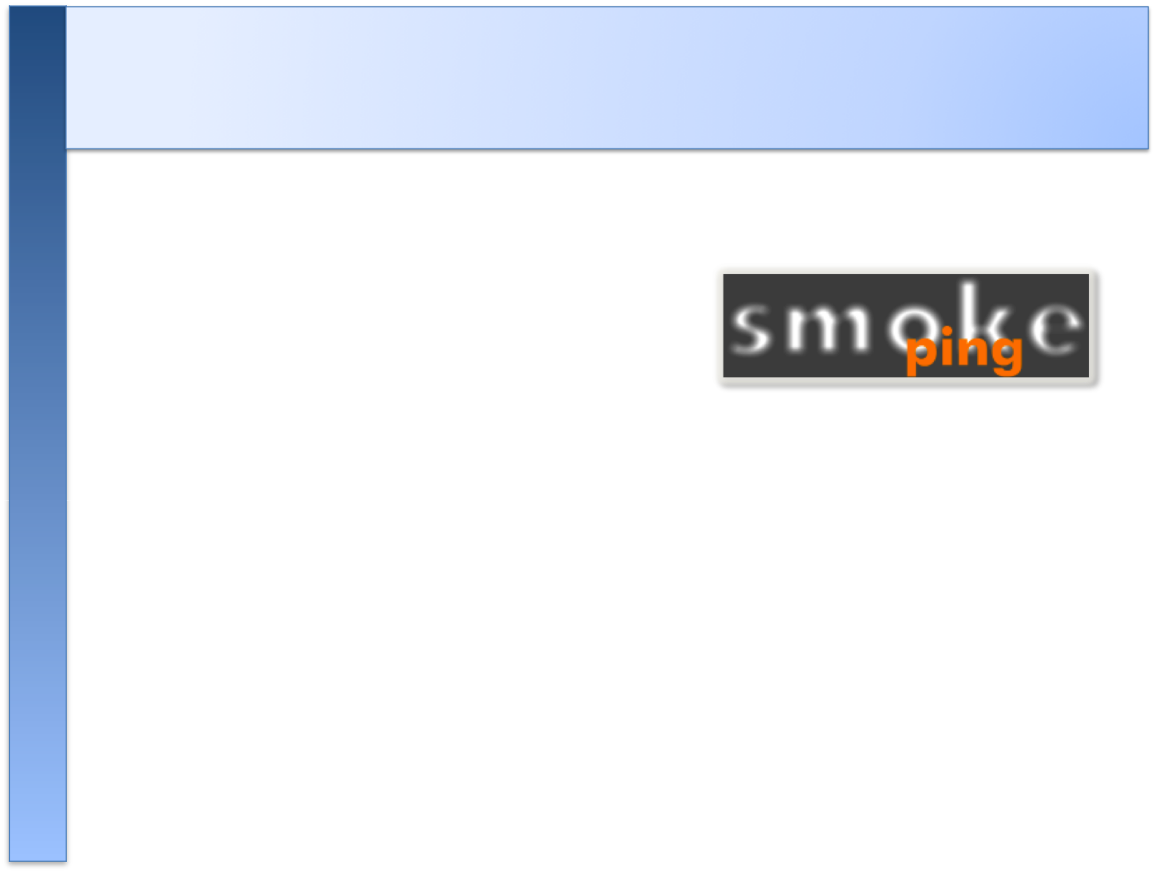
Introduction: “Marketing”

• SmokePing keeps track of your network latency:

• Best of breed latency visualization.

• Interactive graph explorer.

• Wide range of latency measurement plugins.

• Master/Slave System for distributed measurement.

• Highly configurable alerting system.

• Live Latency Charts with the most 'interesting' graphs.

• Free and OpenSource Software written in Perl written by Tobi Oetiker, the creator of MRTG and RRDtool

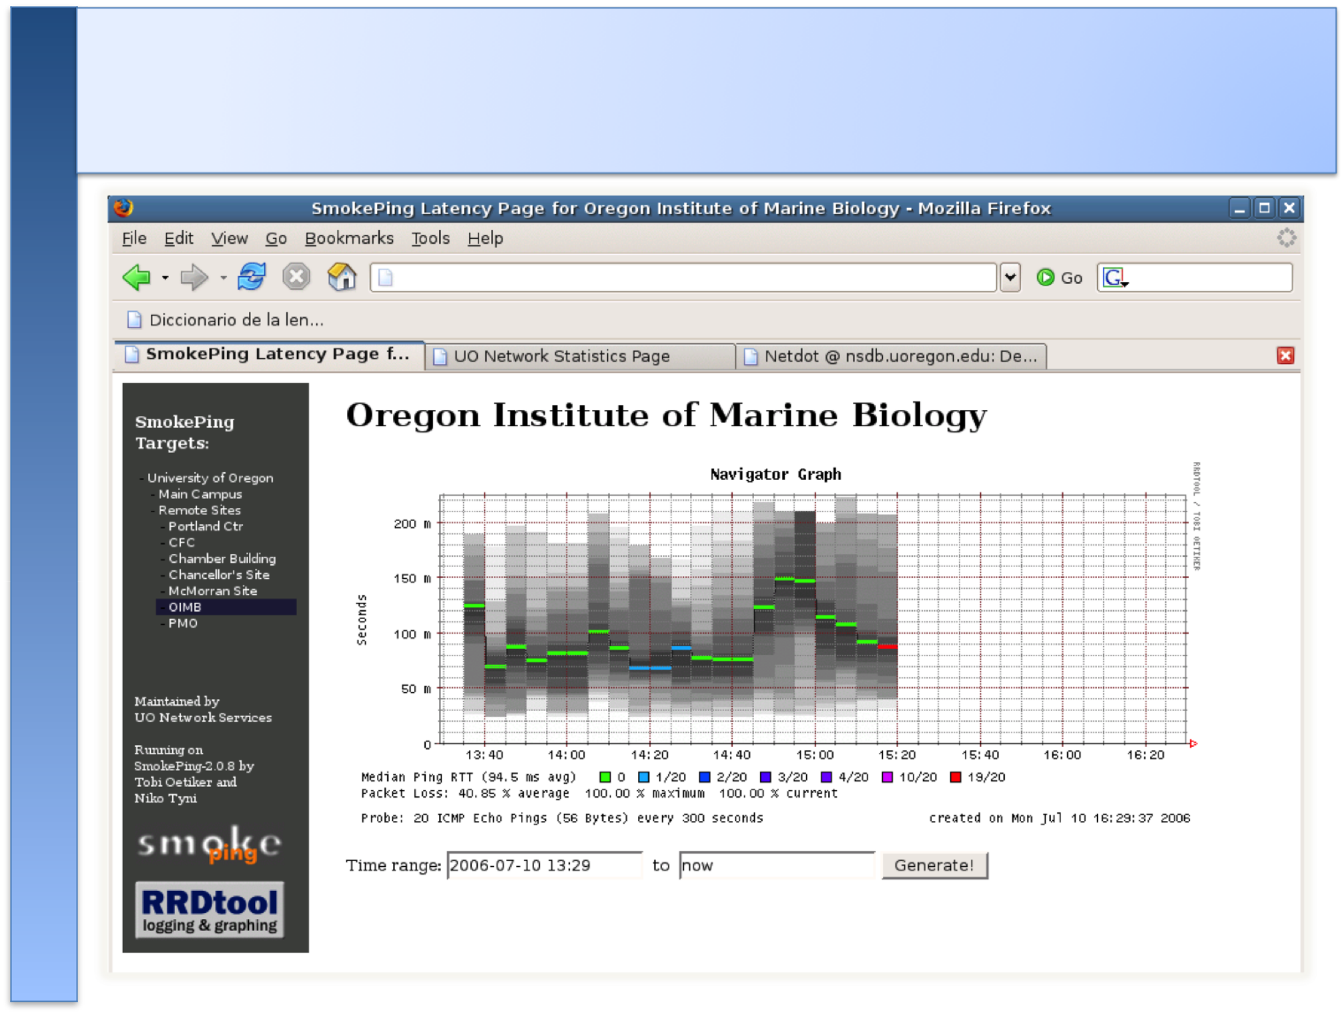
The “Smoke” and the “Pings”
How to Read Smokeping Graphs How to Read Smokeping Graphs

● Smokeping sends multiples tests (pings), makes note of RTT, orders these and selects the median.

● The different values of RTT are shown graphically as lighter and darker shades of grey (the “smoke”). This conveys the idea of variable round trip times or jitter.

● The number of lost packets (if any) changes the color of the horizontal line across the graph.
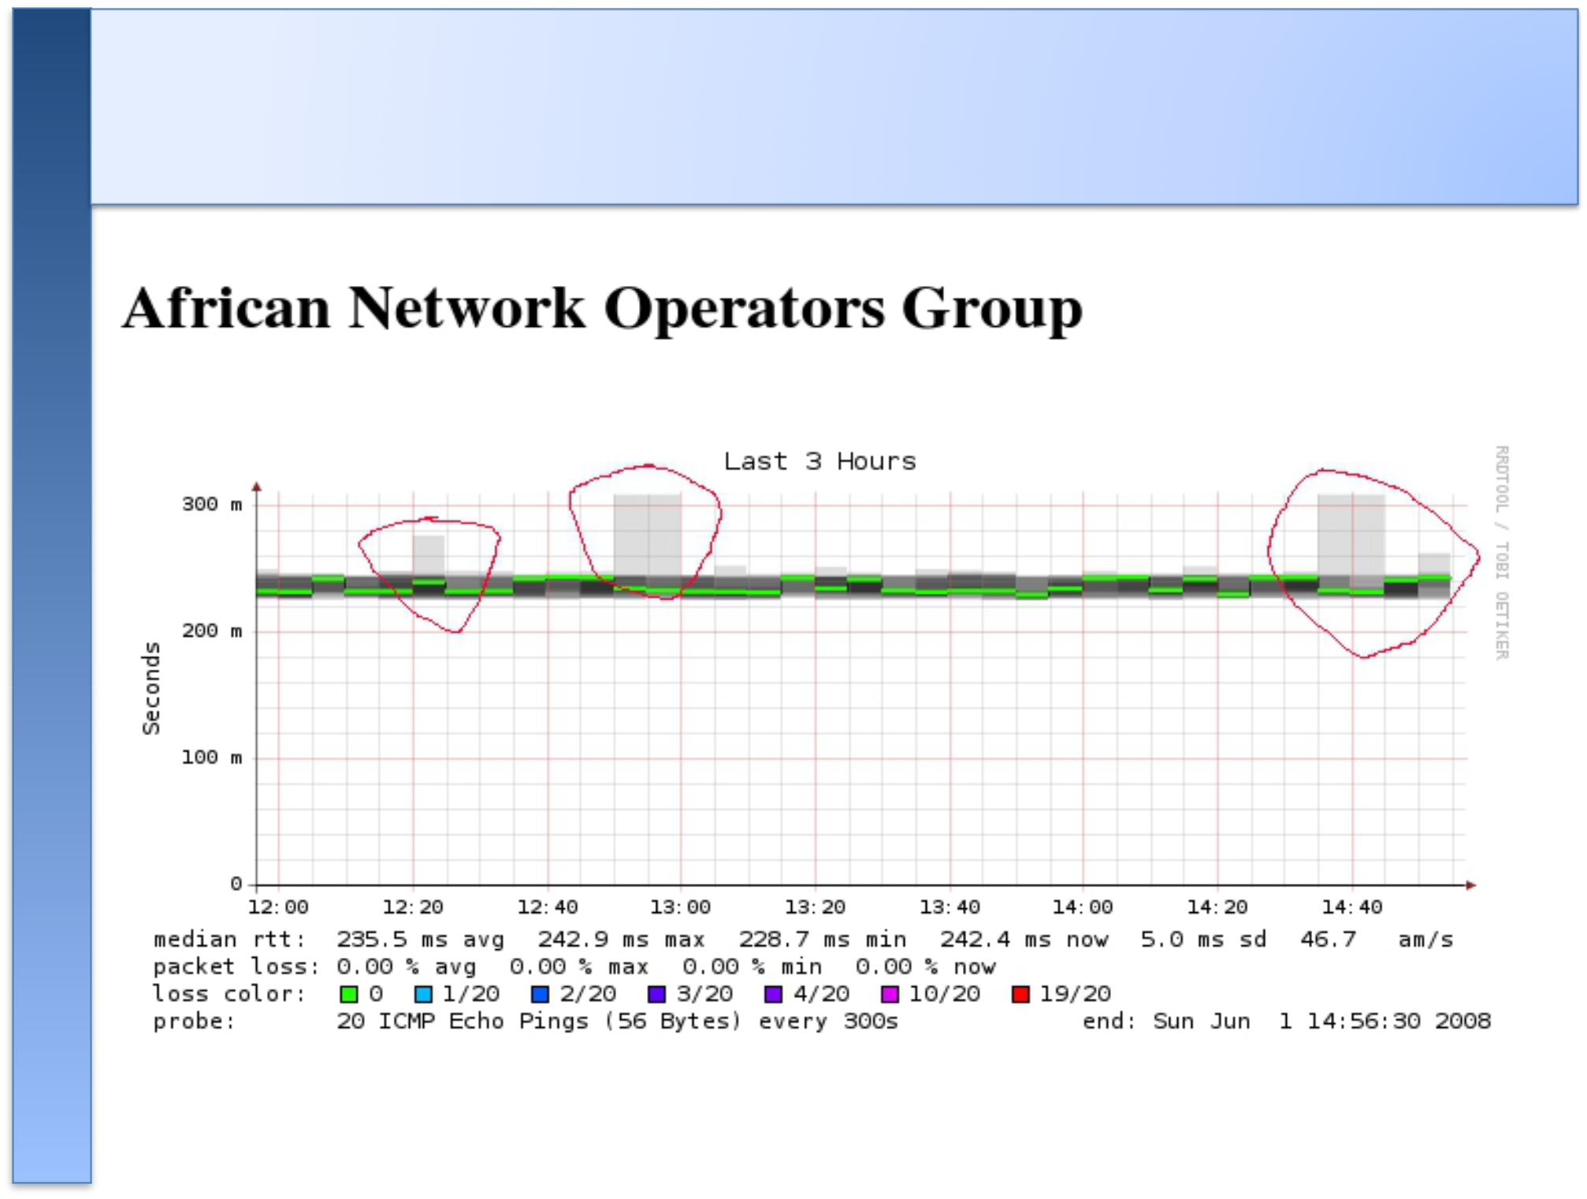
An Example

What makes it tick!

The following packages are needed or recommended:

- rrdtool http://oss.oetiker.ch/rrdtool/

- fping http://www.fping.com/

- echoping http://echoping.sourceforge.net/

- speedyCGI http://www.daemoninc.com/SpeedyCGI/

- Apache http://httpd.apache.org/

- Perl http://www.perl.org/

Smokeping: Installation

Debian/Ubuntu:

● apt-get install smokeping

● Configure /etc/smokeping/config.d/*  Change Smokeping's appearance here:

- /etc/smokeping/basepage.html  Restart the service:

- /etc/init.d/smokeping restart - /etc/init.d/smokeping reload

- service smokeping restart/reload

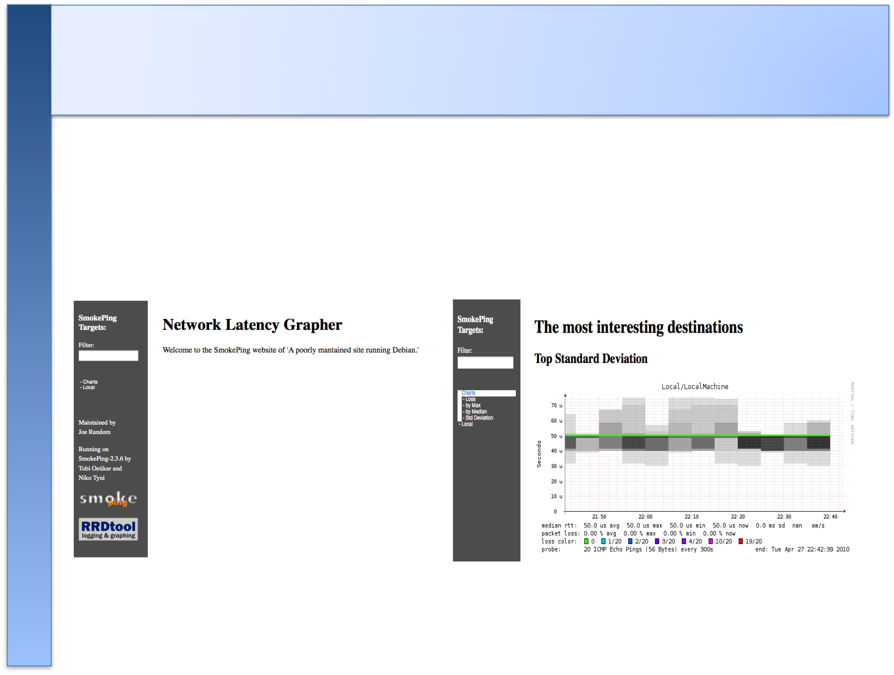
Smokeping Installation

You will find Smokeping running here:

http://pcN.ws.ccun.edu.kh/cgi-bin/smokeping.cgi
Configuration

Smokeping configuration files in Ubuntu

10.04 include:

/etc/smokeping/config.d/Alerts /etc/smokeping/config.d/Database /etc/smokeping/config.d/General /etc/smokeping/config.d/pathnames /etc/smokeping/config.d/Presentation /etc/smokeping/config.d/Probes /etc/smokeping/config.d/Slaves /etc/smokeping/config.d/Targets

Generally we spend most of our time in Alerts, General, Probes and Targets.


Configuration: General

Update:
• owner | ➔ | NOC
• contact | ➔ | sysadm@localhost
• cgiurl | ➔ | http://localhost/cgi-bin/smokeping.cgi
• mailhost | ➔ | localhost
• syslogfacility | ➔ | local5

*** General ***

@include /etc/smokeping/config.d/pathnames

# Please edit this to suit your installation

owner = NOC

contact = sysadm@localhost

cgiurl = http://localhost/cgi-bin/smokeping.cgi

mailhost = localhost

- specify this to get syslog logging syslogfacility = local5

- each probe is now run in its own process

- disable this to revert to the old behaviour

- concurrentprobes = no

Configuration: pathnames

Normally you should not need to update this file:

sendmail = /usr/sbin/sendmail

imgcache | = /var/www/smokeping
imgurl | = ../smokeping
datadir | = /var/lib/smokeping
dyndir | = | /var/lib/smokeping/__cgi
piddir | = | /var/run/smokeping
smokemail = /etc/smokeping/smokemail

tmail = /etc/smokeping/tmail

precreateperms = 2775

Configuration: Presentation

• If you wish to customize Smokeping’s look and feel you can edit the file /etc/smokeping/basepage.html
• To change how Smokeping presents graphs you can edit this file.

*** Presentation ***

template = /etc/smokeping/basepage.html

+ charts

menu = Charts

title = The most interesting destinations

++ stddev

sorter = StdDev(entries=>4)

title = Top Standard Deviation

menu = Std Deviation

format = Standard Deviation %f

++ max

sorter = Max(entries=>5)

title = Top Max Roundtrip Time

menu = by Max

format = Max Roundtrip Time %f seconds
File continues…

Configuration: Alerts

• Very flexible. Create your own type of alert.

• Send alerts to ticket queues (RT using rt-mailgate, for instance)

• Somewhat complex to understand. Read the Alerts section of the Smokeping on-line configuration documentation:
http://oss.oetiker.ch/smokeping/doc/smokeping_config.en.html

*** Alerts ***

to = net@localhost

from = smokeping-alert@localhost

+bigloss

type = loss

# in percent

pattern = ==0%,==0%,==0%,==0%,>0%,>0%,>0% comment = suddenly there is packet loss

+someloss

type = loss

# in percent

pattern = >0%,*12*,>0%,*12*,>0%

comment = loss 3 times in a row over 12 samples

Remember this goes to our RT queue.

Ubuntu-specific alert. The name is misleading as the alert is for any loss when there was none previously.

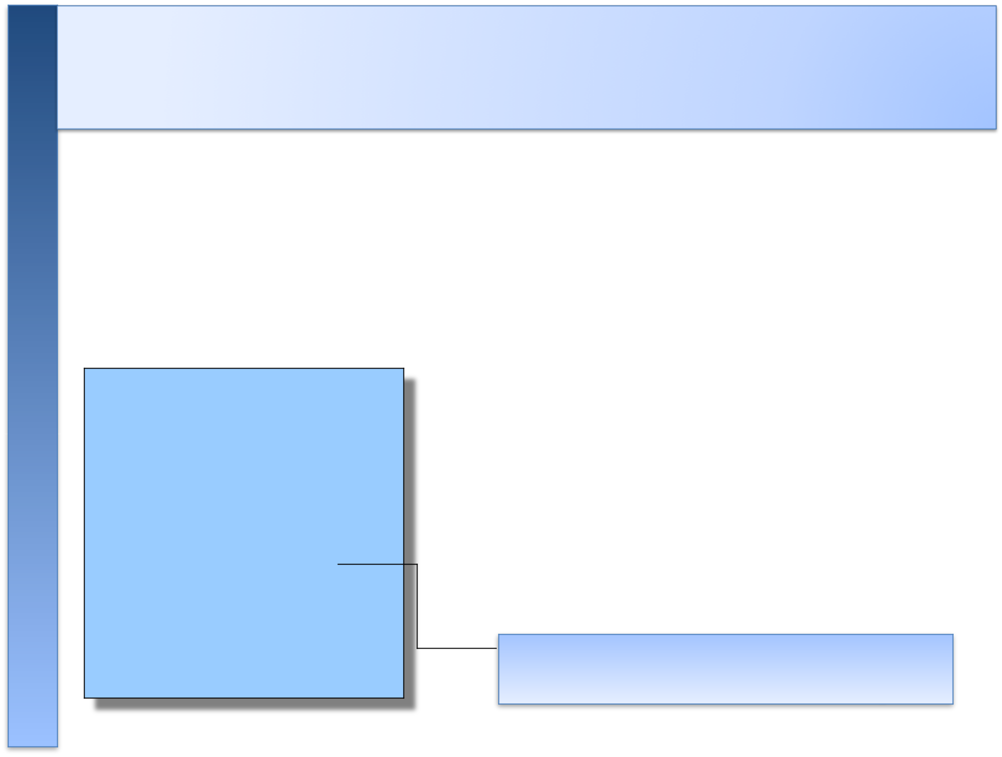
Configuration: Database

• Defines how RRDtool will save data over time in Round Robin Archives (RRAs)

• By default each step is 300 seconds (5 minutes).

• You cannot trivially change the step setting once data has been collected.

• Details on each column in the Database section of the Smokeping on-line

• configuration documentation:

http://oss.oetiker.ch/smokeping/doc/smokeping_config.en.html

*** Database ***

step | = | 300
pings | = | 20

# consfn mrhb steps total

AVERAGE 0.5 1 1008

AVERAGE 0.5 12 4320

MIN 0.5 12 4320

MAX 0.5 12 4320

AVERAGE 0.5 144 720

MAX 0.5 144 720

MIN 0.5 144 720

consfn: Consolidation function

mrhb: Percent of consolidated steps that must be known to warrant an entry.
steps: How many steps to consolidate for each entry in the RRA.
total: Total number of rows to keep in the RRA. Use rows and steps to determine time data will be saved.

12 steps = 12 x 300 sec = 1 hour

4320 rows = 4320 hours = 180 days

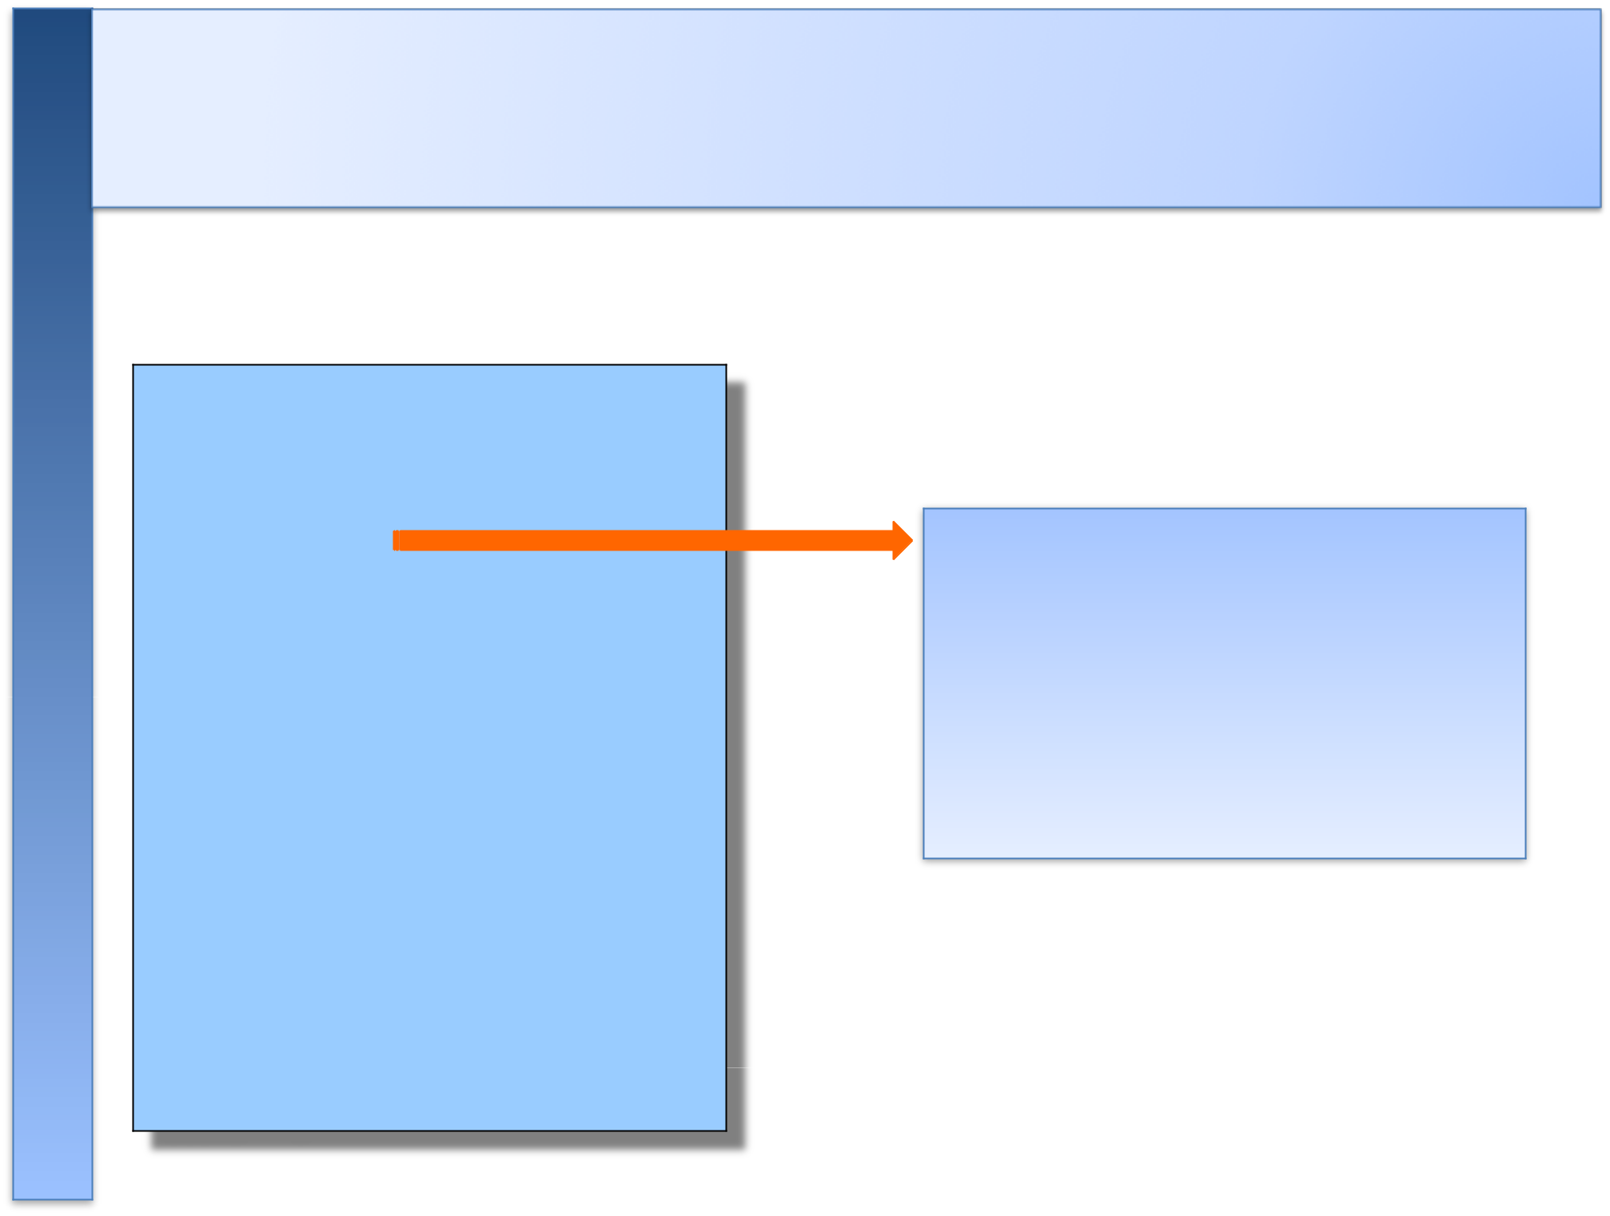
Configuration: Probes

Smokeping is installed with a number of additional probes. They must, however, be specified here – including their default behaviors.

*** Probes ***

+ FPing

binary = /usr/sbin/fping

+ DNS

binary = /usr/bin/dig
lookup = nsrc.org

pings = 5

step = 180

+ EchoPingHttp

binary = /usr/bin/echoping ignore_cache = yes pings = 5

url = /

+ EchoPingHttps

binary = /usr/bin/echoping

pings = 5

url = /

+ EchoPingSmtp

binary = /usr/bin/echoping
forks = 5

Use the DNS probe to verify that your services are available and responding as expected.

We use ”nsrc.org” as a sample hostname to lookup, to verify that the DNS works.

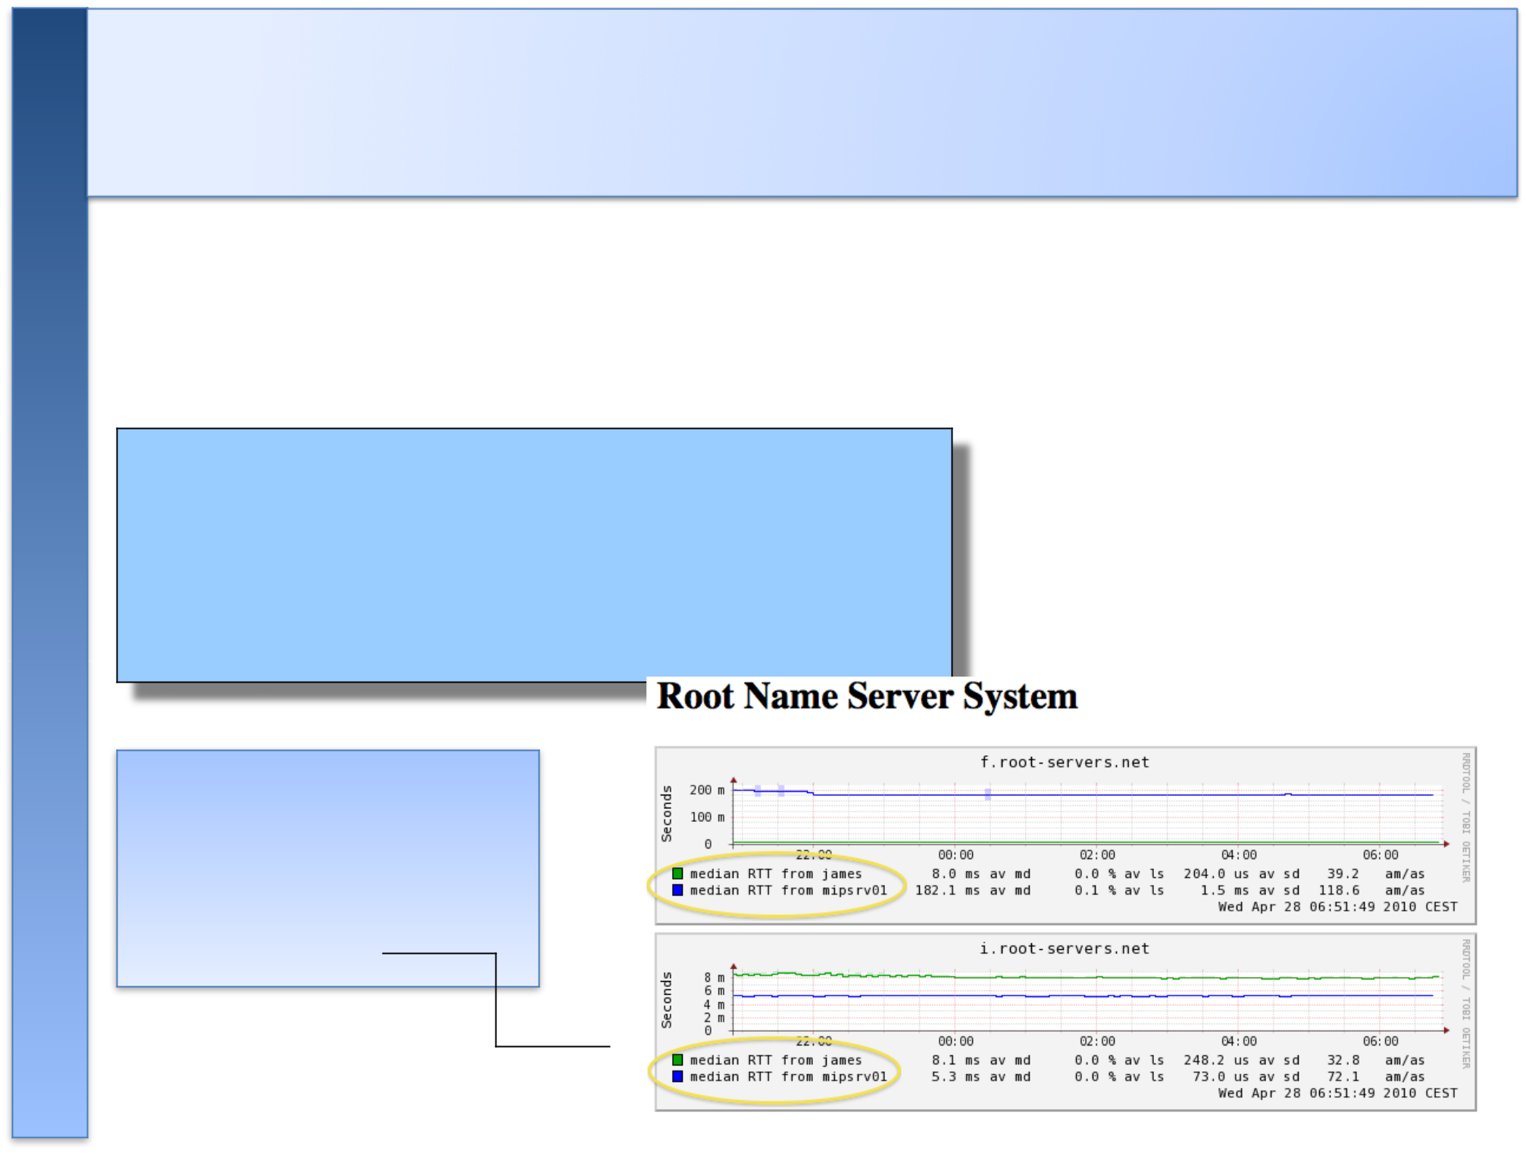
Configuration: Slaves

Smokeping slave servers allow for multi-viewpoint monitoring and graphing of the same services, machines or links. Details here:

http://oss.oetiker.ch/smokeping/doc/smokeping_master_slave.en.html

- *** Slaves ***

## make sure this is not world-readable! ## secrets=/etc/smokeping/slave-secrets

- +slave1

- display_name=slave_name

- color=0000ff

That is, you can externally monitor your network!

Configuration: Targets

• Where we spend most of our time configuring Smokeping.

• Web menu hierarchy defined by “+”, “++”, etc.

• Each new probe statement resets the default probe in use.

• Probes have defaults set in the Probes config file. These can be overridden in Targets.

*** Targets ***

probe = FPing

menu = Top

title = Network Latency Grapher

+ UO

menu = University of Oregon title = UO webserver
host = www.uoregon.edu

- NSRC menu = NSRC
title = Network Startup Resource Center host = www.nsrc.org

- HTTP menu = HTTP
probe = EchoPingHttp

+++ www

menu = NSRC web
host = www.nsrc.org

- DNS menu = DNS probe = DNS

+++ dns

menu = NSRC DNS

host = www.nsrc.org

Default Probe: FPing

Probing for delay and jitter (ping)

Performance and availability probe of a server.
Entry belongs in the Targets file:

Latency

+++ LocalMachine

menu = localhost

title = Our local machine

host = localhost

alerts = startloss,someloss,bigloss,rttdetect

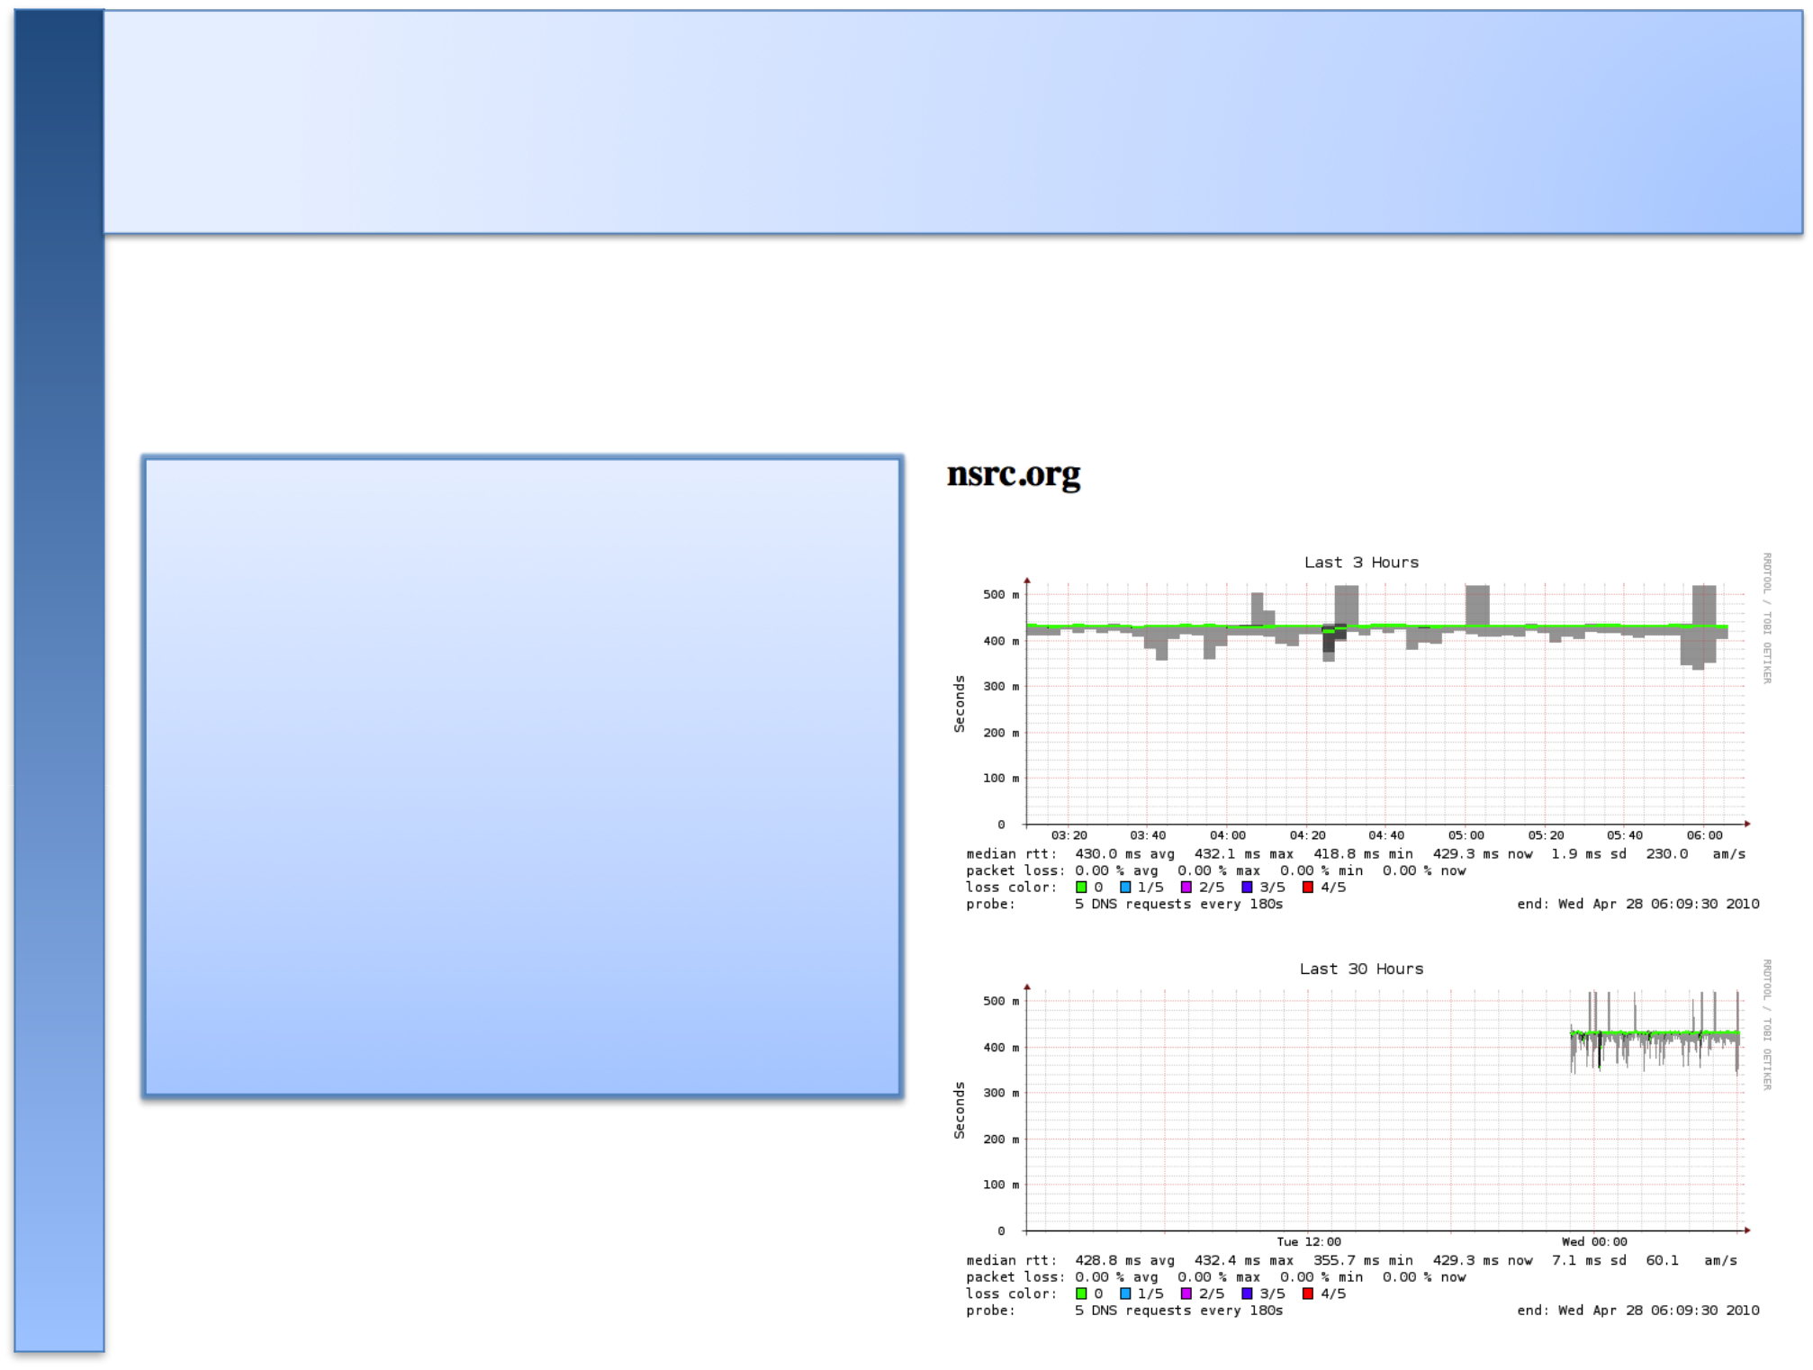
Probe: DNS Check

In /etc/smokeping/config.d/Targets:

DNS Latency

- DNS probe = DNS
menu = External DNS Check title = DNS Latency

+++ ccun

host = ccun.edu.kh
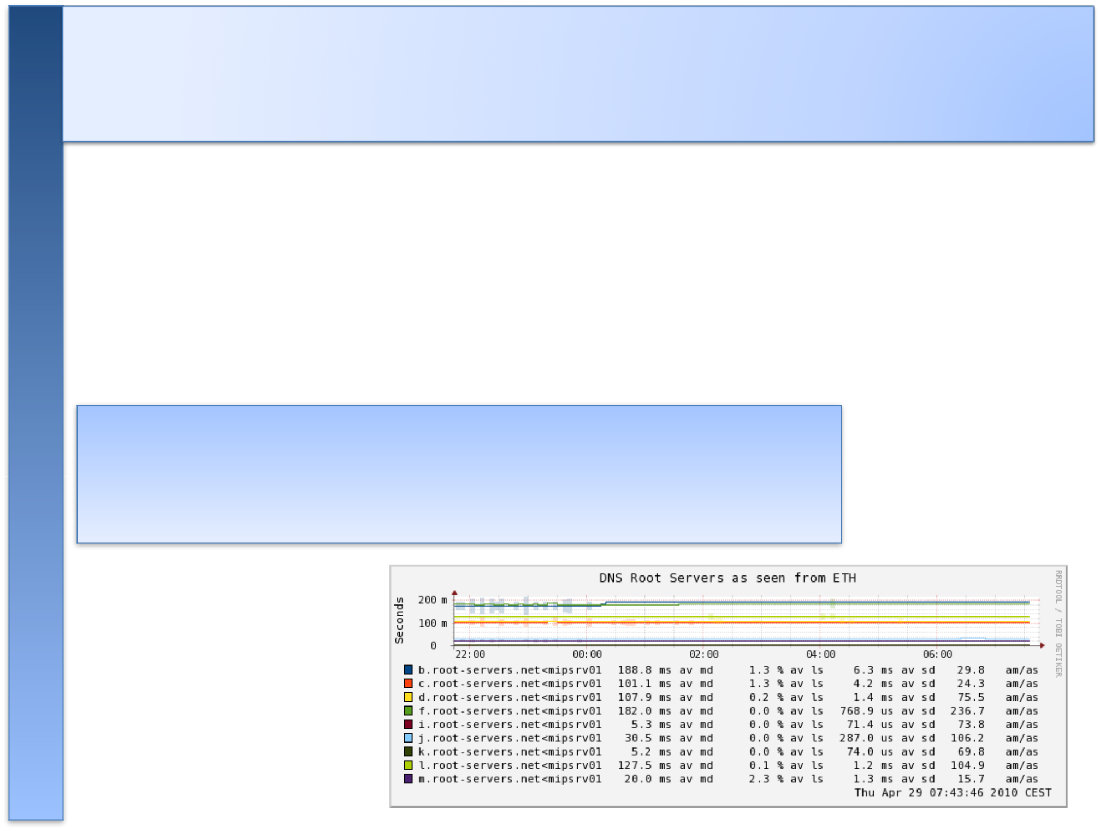
MultiHost Graphing

Solve the issue of multiple hosts, one probe and missing differences in the Y axis (time):

http://oss.oetiker.ch/smokeping/doc/smokeping_examples.en.html

Sample configuration

+++MultihostRouters

menu = MutihostRouters

title = Combined Router Results

host = /Local/Routers/gw-rtr /Local/Routers/rtr1 /Local/Routers/rtr2
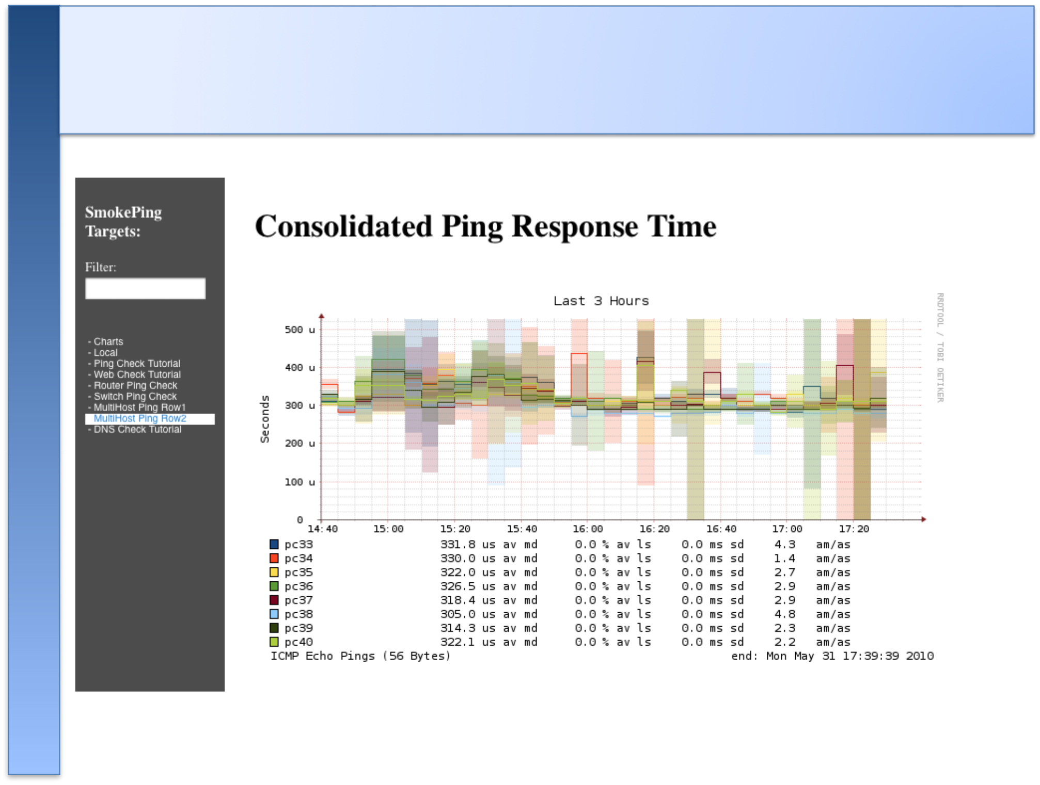
Example Multihost Graph
More Types of Probes

More information available here:

http://oss.oetiker.ch/smokeping/probe/index.en.html

A few more probes...

- DNS | - CiscoRTTMonDNS | - Radius
- HTTP(S) | - CiscoRTTMonTcpCon | - IOS
- LDAP | - Tacacs | - FPing6
- Whois | - WebProxyFilter | - Etc.
- SMTP | - WWW-Cache

Summary

• Simple but powerful network monitoring

• Monitor machines, services and link health

• Distributed instances for external views – often a paid-for service

• Easy to configure and customize, but very extensible.

• Can be used with Ticketing Systems to automate alerts

• Very small disk and CPU footprint
References

Smokeping website:

http://oss.oetiker.ch/smokeping/

Smokeping Demo:

http://oss.oetiker.ch/smokeping-demo/?target=Customers.OP

Good examples:

http://oss.oetiker.ch/smokeping/doc/smokeping_examples.en.html

