Network Management &

Monitoring

Netflow

NetFlow Overview

These materials are licensed under the Creative Commons Attribution-Noncommercial 3.0 Unported license (http://creativecommons.org/licenses/by-nc/3.0/)


Agenda

Netflow

– What it is and how it works

– Uses and Applications

Flow-tools

– Architectural issues

– Software, tools etc

Lab

Network Flows

• Packets or frames that have a common attribute.

• Creation and expiration policy – what conditions start and stop a flow.

• Counters – packets, bytes, time.

• Routing information – AS, network mask, interfaces.


Cisco’s Definition of a Flow

Unidirectional sequence of packets sharing

- Source IP address

- Destination IP address

- Source port for UDP or TCP, 0 for other protocols

- Destination port for UDP or TCP, type and code for ICMP, or 0 for other protocols

- IP protocol

- Ingress interface (SNMP ifIndex)

- IP Type of Service

Network Flows

• Unidirectional or bidirectional.

• Bidirectional flows can contain other information such as round trip time, TCP behavior.
• Application flows look past the headers to classify packets by their contents.

• Aggregated flows – flows of flows.

Working with Flows

• Generate the flows from device (usually a router)

• Export flows from the device to collector

– Configure version of flows – Sampling rates

• Collect the flows

– Tools to Collect Flows - Flow-tools

• Analyze them

– More tools available, can write your own

Flow Descriptors

• A Key with more elements will generate more flows.

• Greater number of flows equals:

– More post processing time to generate reports

– more memory and CPU requirements for device generating flows
– More storage needed on the flow processing server

• Depends on application. Traffic engineering vs. intrusion detection.

Flow Accounting

• Accounting information accumulated with flows.

• Packets, Bytes, Start Time, End Time.

• Network routing information – masks and autonomous system number.

Flow Generation/Collection

Passive monitor

• A passive monitor (usually a Unix host) receives all data and generates flows.
• Resource intensive

Router or other existing network device

• Router or other existing devices like switch, generate flows.
• Sampling is possible

• Nothing new needed

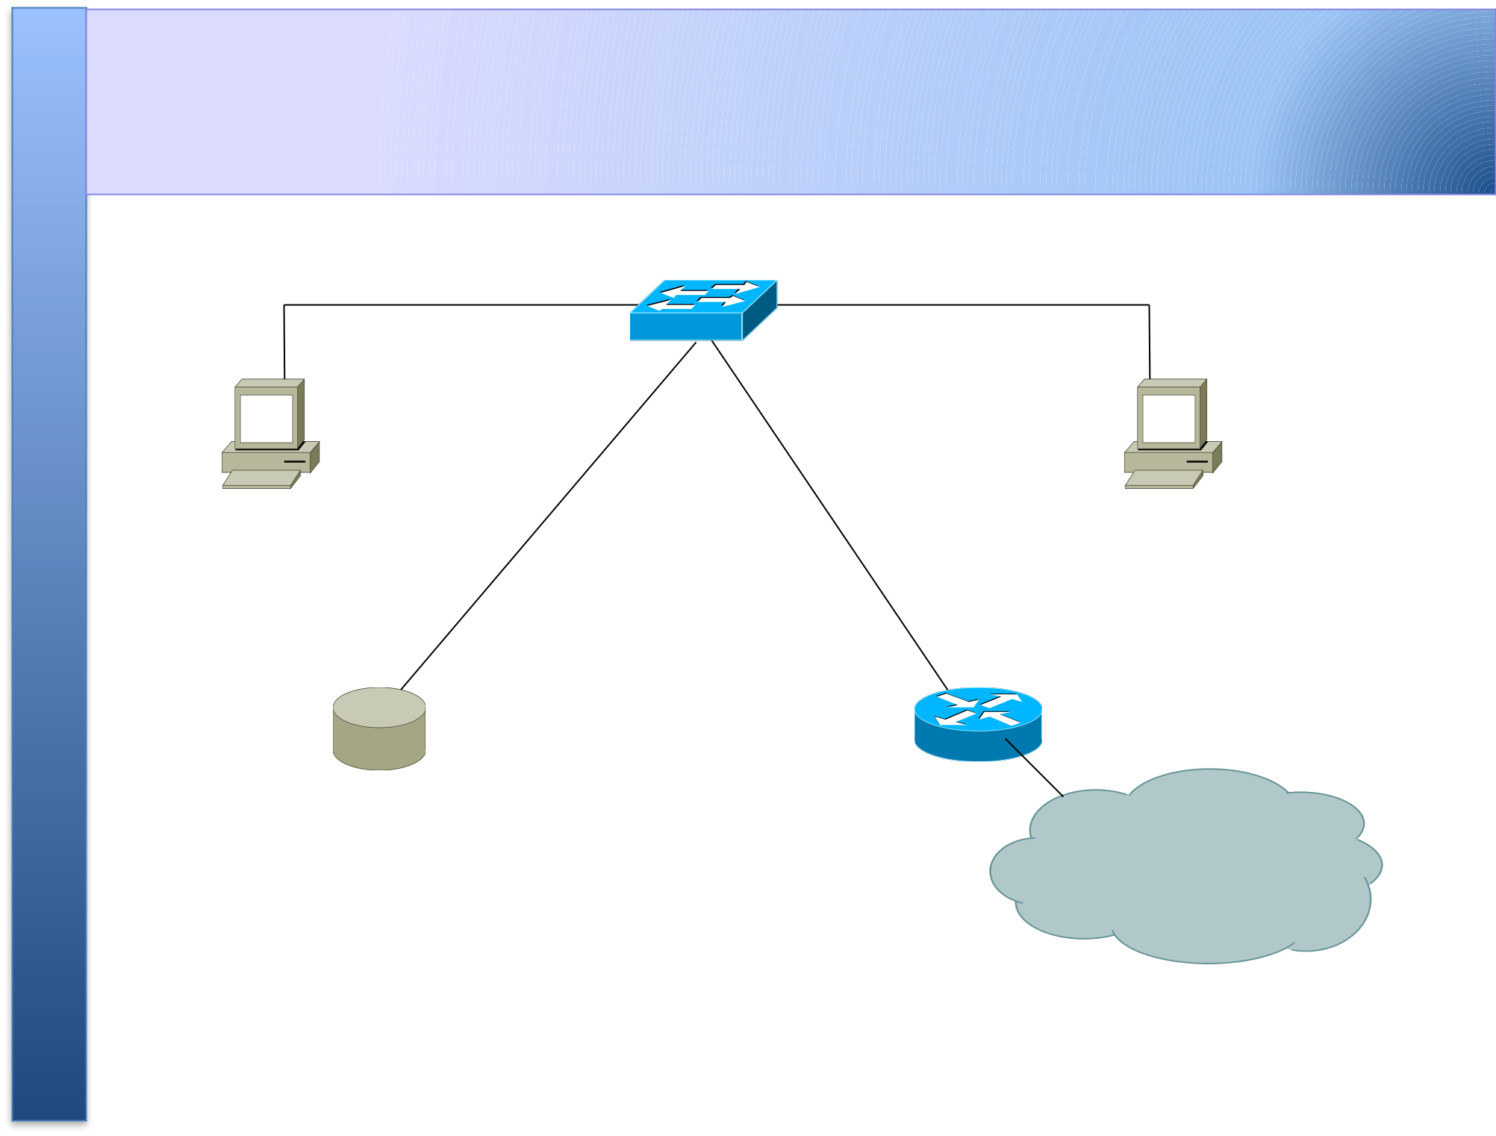
Passive Monitor Collection

Workstation A Workstation B

Flow probe connected
to switch port in ^{Campus} “ traffic mirror” mode

Passive Collector

• Using passive collection, not all flows in the network will be seen as opposed to collection from the router

• The collector will only see flows from the network point it is connected on

• However this method does relieve the router from processing netflows and exporting them

• Useful on links with only one entry into the network or where only flows from one section of the network are needed

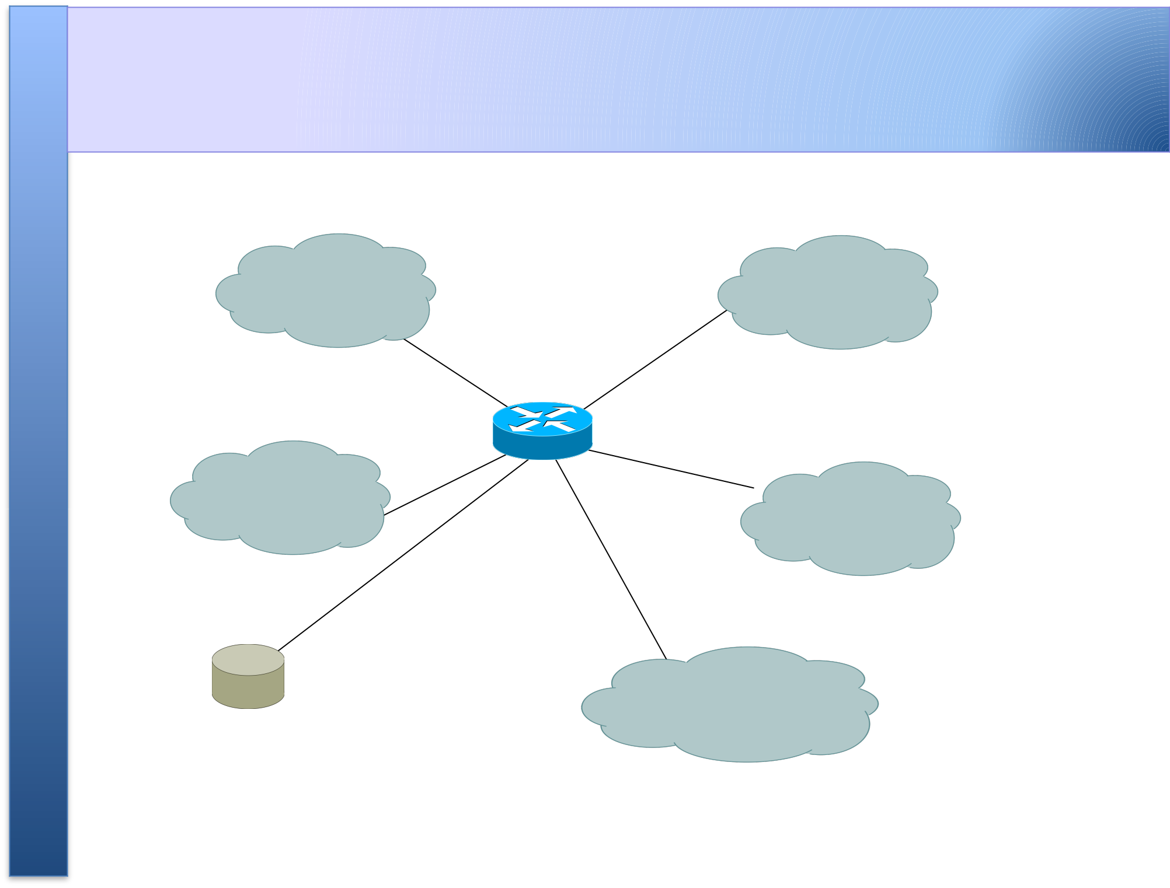
Router Collection

LAN LAN

LAN | LAN

Internet

Flow collector

stores exported flows from router.

Router Collection

• With this method, all flows in the network can be observed

• However, more work for the router in processing and exporting the flows

• Optionally, one can choose on which interfaces netflow collection is needed and not activate it on others

• Also, if there is a router on each LAN, netflow can be activated on those routers to reduce the load on the core router

Cisco NetFlow

• Unidirectional flows.

• IPv4 unicast and multicast.

• Aggregated and unaggregated.

• Flows exported via UDP.

• Supported on IOS and CatOS platforms.

• Catalyst NetFlow is different implementation.

Cisco NetFlow Versions

• 4 Unaggregated types (1,5,6,7).

• 14 Aggregated types (8.x, 9).

• Each version has its own packet format.

• Version 1 does not have sequence numbers

– no way to detect lost flows.

• The “version” defines what type of data is in the flow.

• Some versions specific to Catalyst platform.

NetFlow Version 1

• Key fields: Source/Destination IP, Source/Destination Port, IP Protocol, ToS, Input interface.

• Accounting: Packets, Octets, Start/End time, Output interface

• Other: Bitwise OR of TCP flags.

• Obsolete

NetFlow Versions 2-4

• Cisco internal

• Were never released
NetFlow v5

• Key fields: Source/Destination IP, Source/Destination Port, IP Protocol, ToS, Input interface.

• Accounting: Packets, Octets, Start/End time, Output interface.

• Other: Bitwise OR of TCP flags, Source/Destination AS and IP Mask.
• Packet format adds sequence numbers for detecting lost exports.
• IPv4 only

NetFlow v8

• Aggregated v5 flows.

• Not all flow types available on all equipments

• Much less data to post process, but loses fine granularity of v5 – no IP addresses.

NetFlow v9

• IPv6 support

• Additional fields like MPLS labels

• Builds on earlier versions

Cisco IOS Configuration

• Configured on each input interface.

• Define the version.

• Define the IP address of the collector (where to send the flows).

• Optionally enable aggregation tables.

• Optionally configure flow timeout and main (v5) flow table size.

• Optionally configure sample rate.

Cisco IOS Configuration

ip flow-top-talkers

top 10

sort-by bytes

gw-169-223-2-0#sh ip flow top-talkers
SrcIf | SrcIPaddress | DstIf | DstIPaddress | Pr SrcP DstP Bytes
Fa0/1 | 169.223.2.2 | Fa0/0 | 169.223.11.33 | 06 | 0050 | 0B64 | 3444K
Fa0/1 | 169.223.2.2 | Fa0/0 | 169.223.11.33 | 06 | 0050 | 0B12 | 3181K
Fa0/0 | 169.223.11.33 | Fa0/1 | 169.223.2.2 | 06 | 0B12 | 0050 | 56K
Fa0/0 | 169.223.11.33 | Fa0/1 | 169.223.2.2 | 06 | 0B64 | 0050 | 55K
Fa0/1 | 169.223.2.2 | Local | 169.223.2.1 | 01 | 0000 | 0303 | 18K
Fa0/1 | 169.223.2.130 | Fa0/0 | 64.18.197.134 | 06 | 9C45 | 0050 | 15K
Fa0/1 | 169.223.2.130 | Fa0/0 | 64.18.197.134 | 06 | 9C44 | 0050 | 12K
Fa0/0 | 213.144.138.195 | Fa0/1 | 169.223.2.130 | 06 | 01BB DC31 |  | 7167
Fa0/0 | 169.223.15.102 | Fa0/1 | 169.223.2.2 | 06 | C917 | 0016 | 2736
Fa0/1 | 169.223.2.2 | Local | 169.223.2.1 | 06 | DB27 0016 |  | 2304
10 of 10 top talkers shown. 49 flows processed.

Cisco Command Summary

• Enable CEF (done by default)

– ip cef

• Enable flow on each interface

ip route cache flow

OR

ip flow ingress

ip flow egress

• View flows

– show ip cache flow

– show ip flow top-talkers
Cisco Command Summary

• Exporting Flows to a collector

ip flow-export version 5 [origin-as|peer-as] ip flow-export destination x.x.x.x <udp-port>

• Origin AS will include the origin AS Number in the flow while Peer AS will only include the AS Number of the peering neighbor

• Exporting aggregated flows

ip flow-aggregation cache as|prefix|dest|source|proto enabled
export destination x.x.x.x <udp-port>

Flows and Applications
Uses for NetFlow

• Problem identification / solving

– Traffic classification

– DoS Traceback (some slides by Danny McPherson)‏
• Traffic Analysis and Engineering

– Inter-AS traffic analysis

– Reporting on application proxies

• Accounting (or billing)

– Cross verification from other sources – Can cross-check with SNMP data

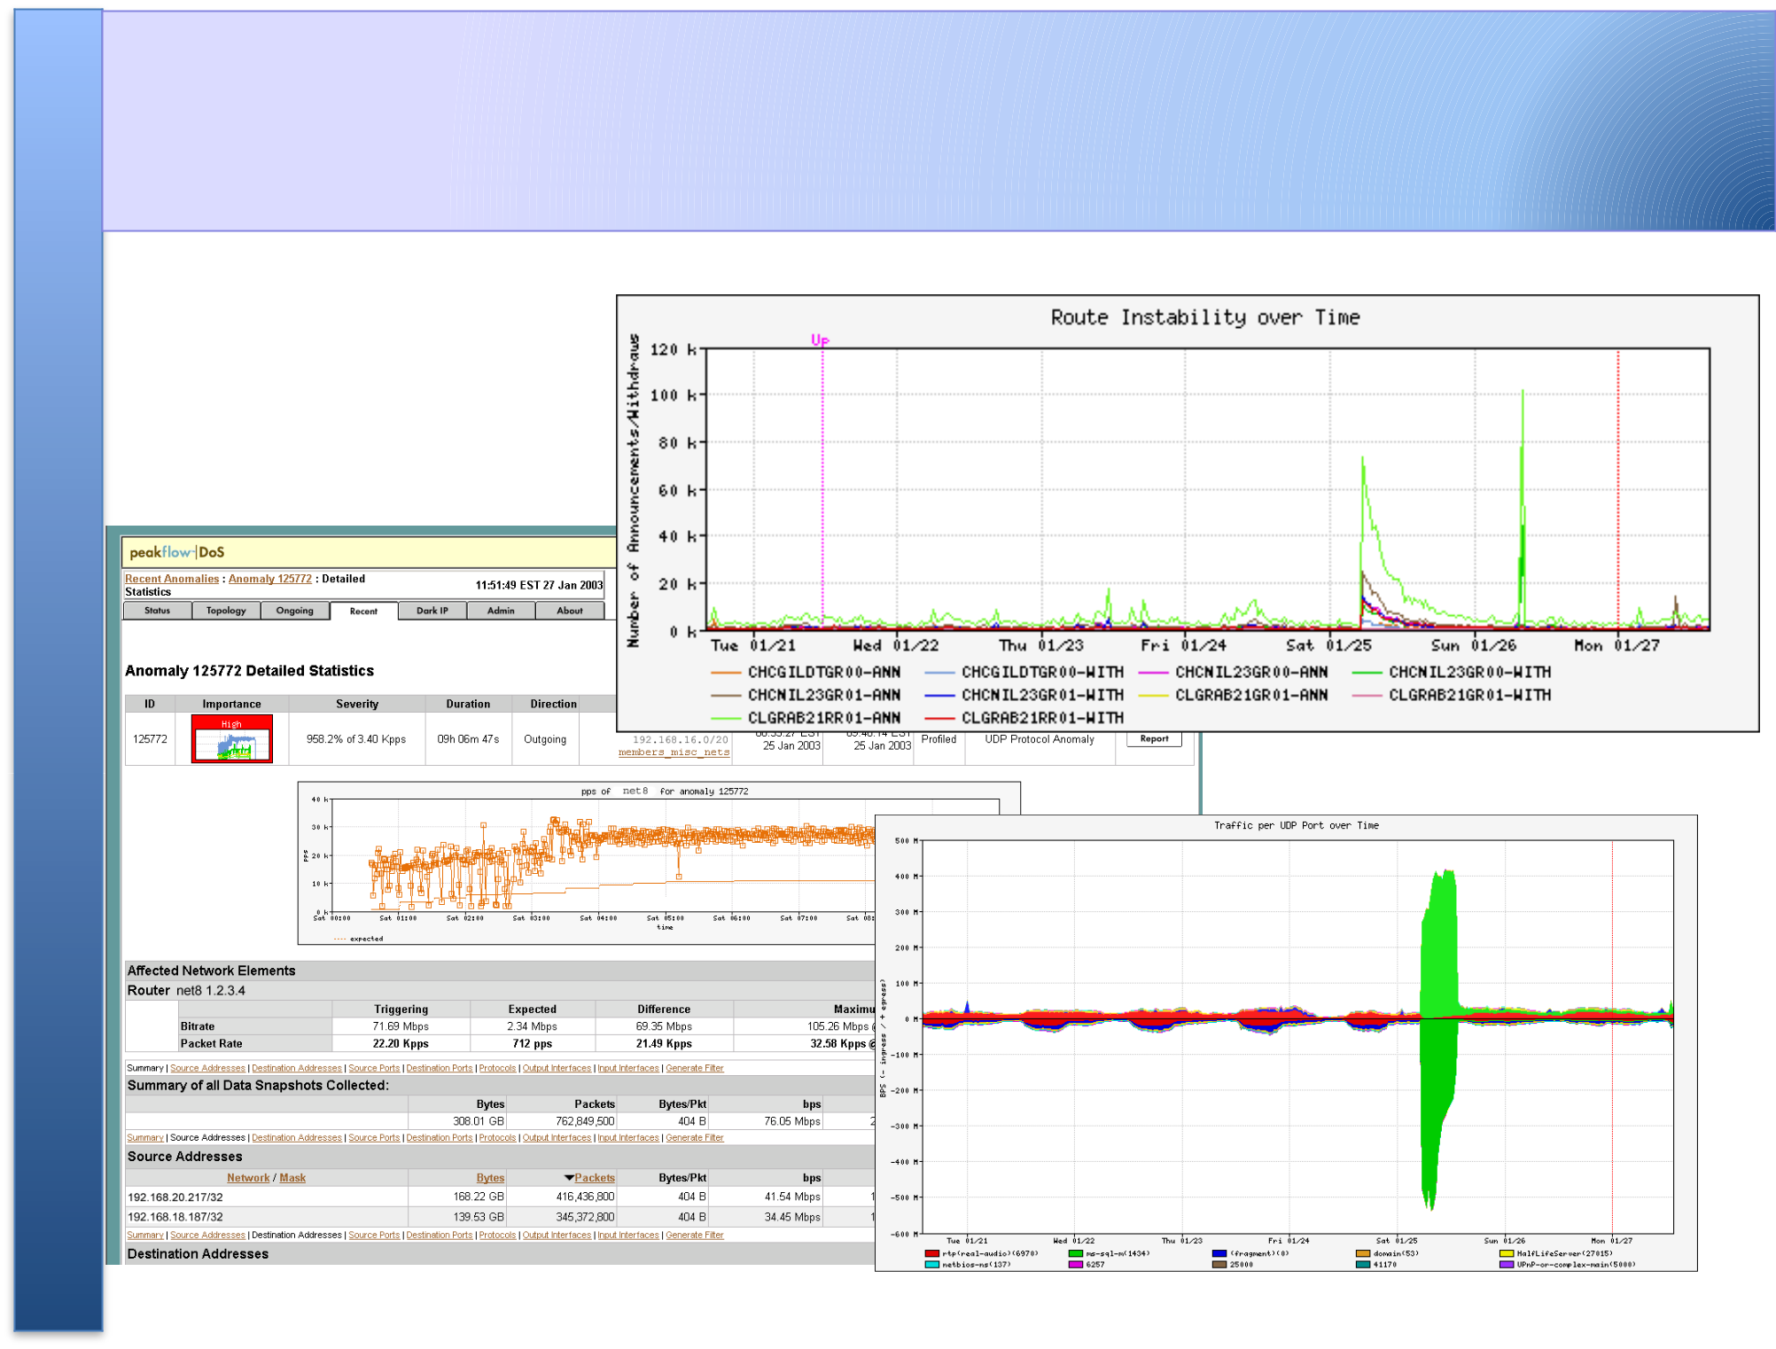
Detect Anomalous Events: SQL “Slammer” Worm*
Flow-based Detection (cont)*

Once baselines are built anomalous activity can be detected

– Pure rate-based (pps or bps) anomalies may be legitimate or

malicious

– Many misuse attacks can be immediately recognized, even without baselines (e.g., TCP SYN or RST floods)‏

– Signatures can also be defined to identify “interesting” transactional data (e.g., proto udp and port 1434 and 404 octets(376 payload) == slammer!)‏

– Temporal compound signatures can be defined to detect with higher precision

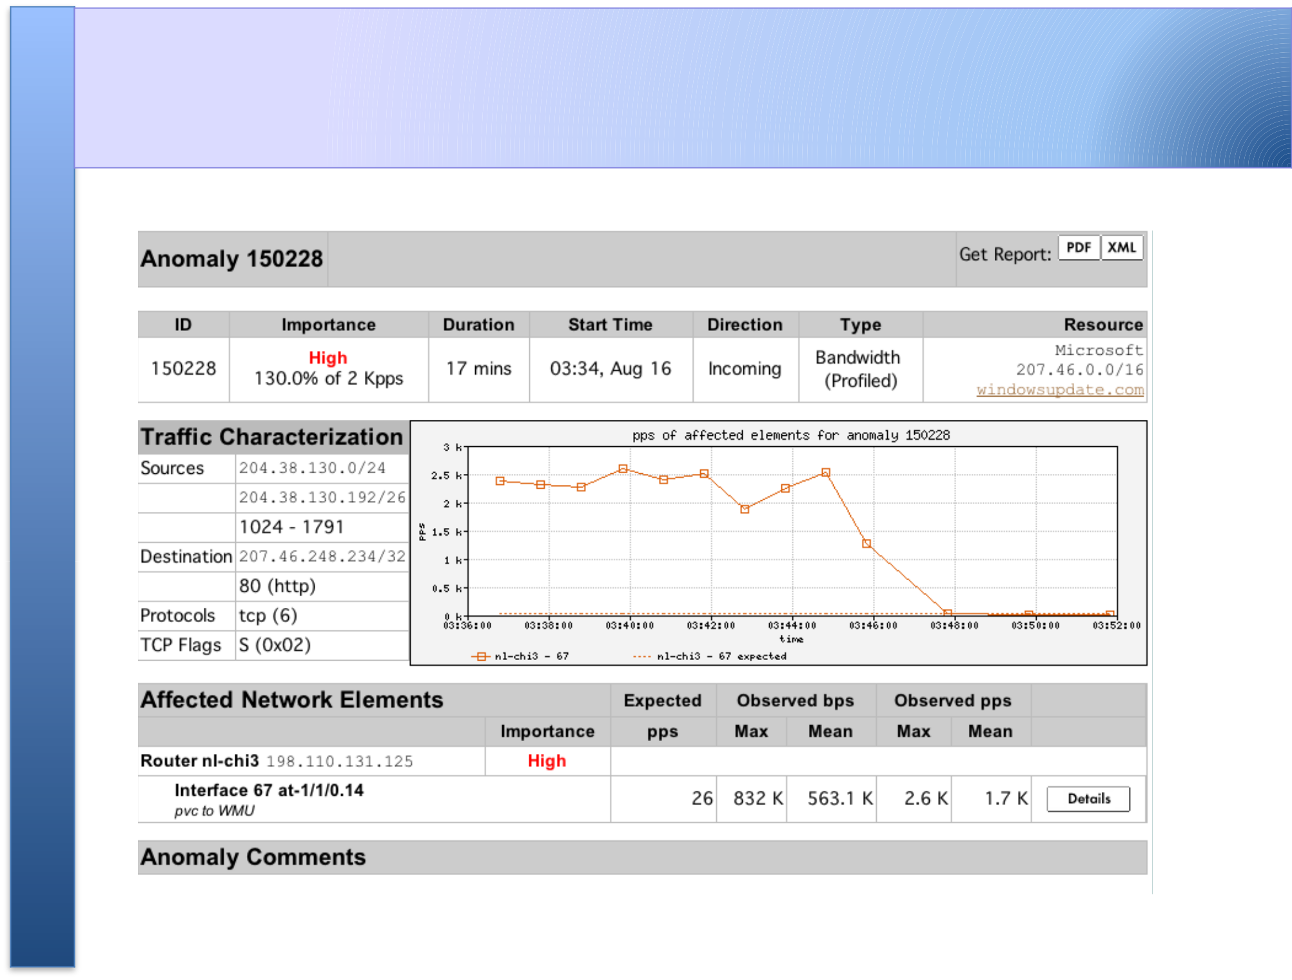
Flow-based Commercial Tools…*
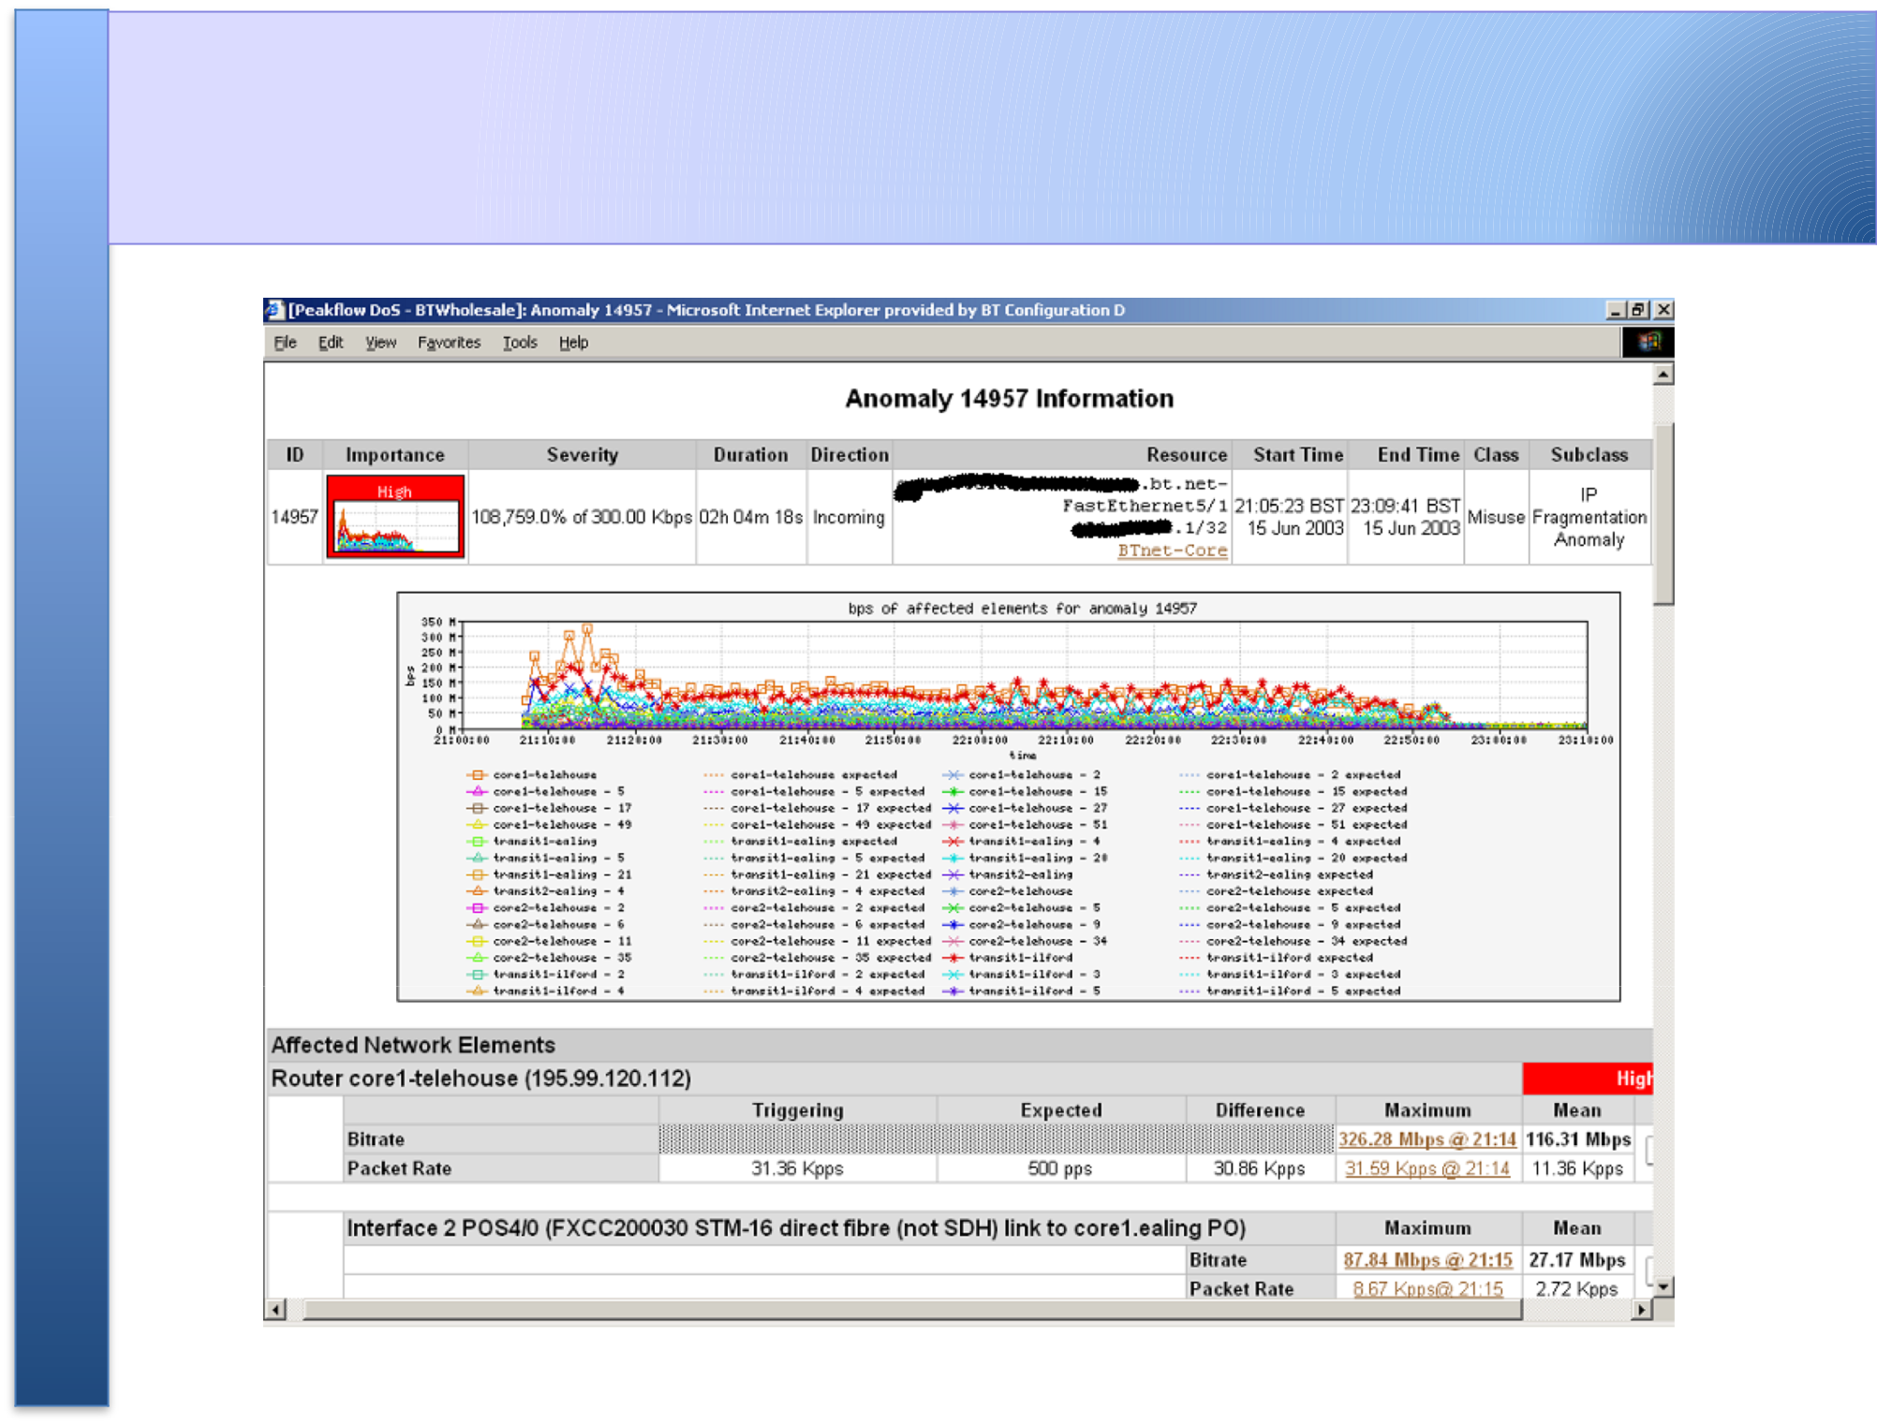
Commercial Detection: A Large Scale DOS Attack
Accounting

Flow based accounting can be a good supplement to SNMP based accounting.

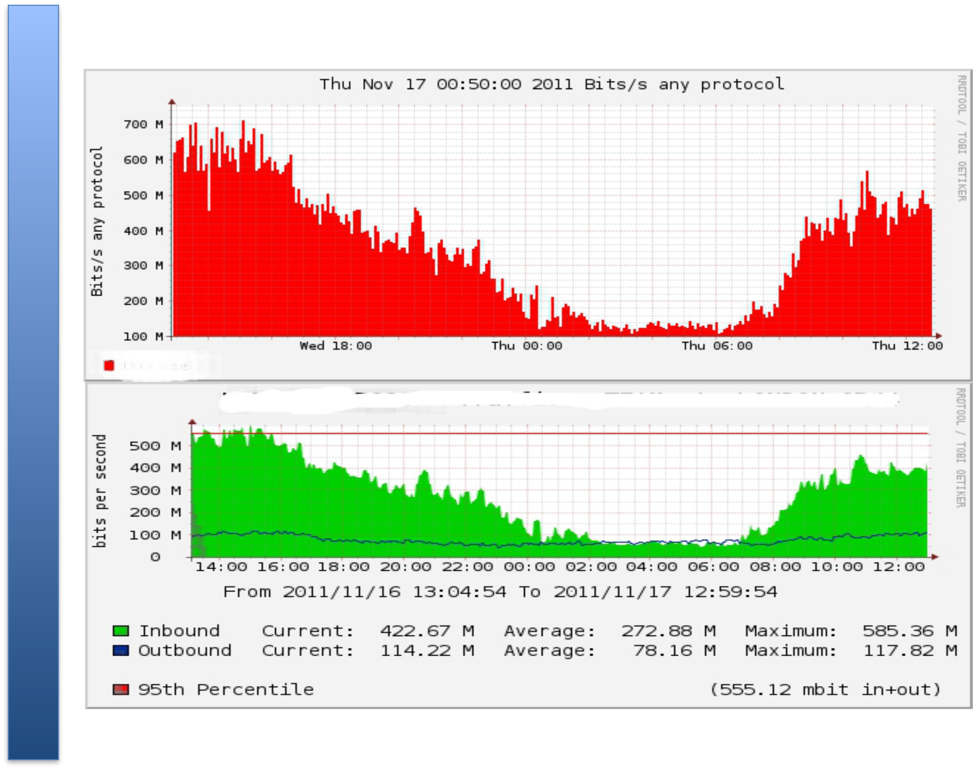
References

• flow-tools:

http://www.splintered.net/sw/flow-tools

• WikiPedia:

http://en.wikipedia.org/wiki/Netflow

• NetFlow Applications

http://www.inmon.com/technology/netflowapps.php

• Netflow HOW-TO

http://www.linuxgeek.org/netflow-howto.php

• IETF standards effort:

http://www.ietf.org/html.charters/ipfix-charter.html

References

• Abilene NetFlow page

http://abilene-netflow.itec.oar.net/

• Flow-tools mailing list:

flow-tools@splintered.net

• Cisco Centric Open Source Community

http://cosi-nms.sourceforge.net/related.html

• Cisco NetFlow Collector User Guide

http://www.cisco.com/en/US/docs/net_mgmt/netflow_collection_engine/6.0/tier_one/ user/guide/user.html

