Campus Network Best Practices:

Hints on Network Diagrams

Cambodian Research and Education Network

.

Network Diagram Hints

• Use separate diagrams for separate layers

– Physical (cabling)

– Switching (layer 2)

– Routing (layer 3)

– Frequently can combine Switching/Routing

• Helpful to have the physical diagram be an overlay on your campus map to show relations and distances between buildings

• If you combine layers 2/3, make it clear where you are switching and where you are routing

Sample Physical Diagram
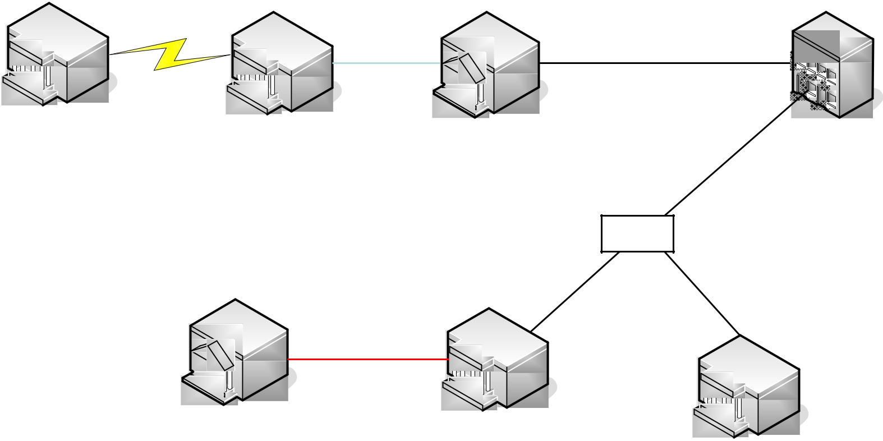

 | 2x |  | 8x62.5 fiber
2.4Ghz 54Mbs | 62.5 fiber
wireless |  |  | 12xG.652.D fiber
 |  |  | Splice
 |  | 4xG.652.D fiber | 4xG.652.D fiber
 | 2x
 | cat5e

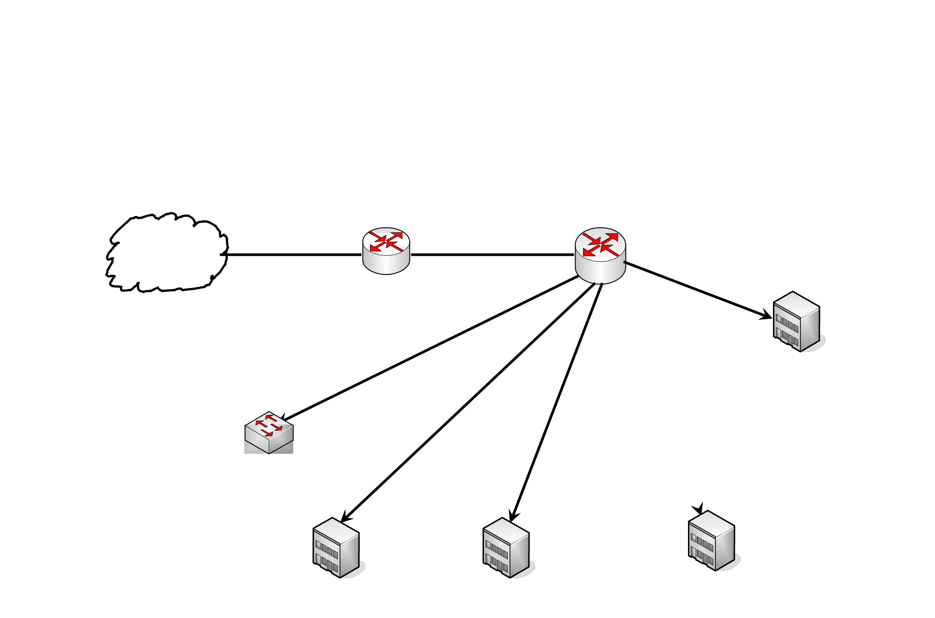
Sample Layer 3 Diagram

ISP

Cisco 2901 Cisco 3750-12D

Border Router (no NAT) Core Router

62.63.64.32/29 128.223.2.64/29

128.223.10.0/24

128.223.20.0/24 Art Faculty

Server Network

128.223.12.0/23

128.223.14.0/24

128.223.16.0/24

Admin Building Social Science General Science Faculty

Faculty

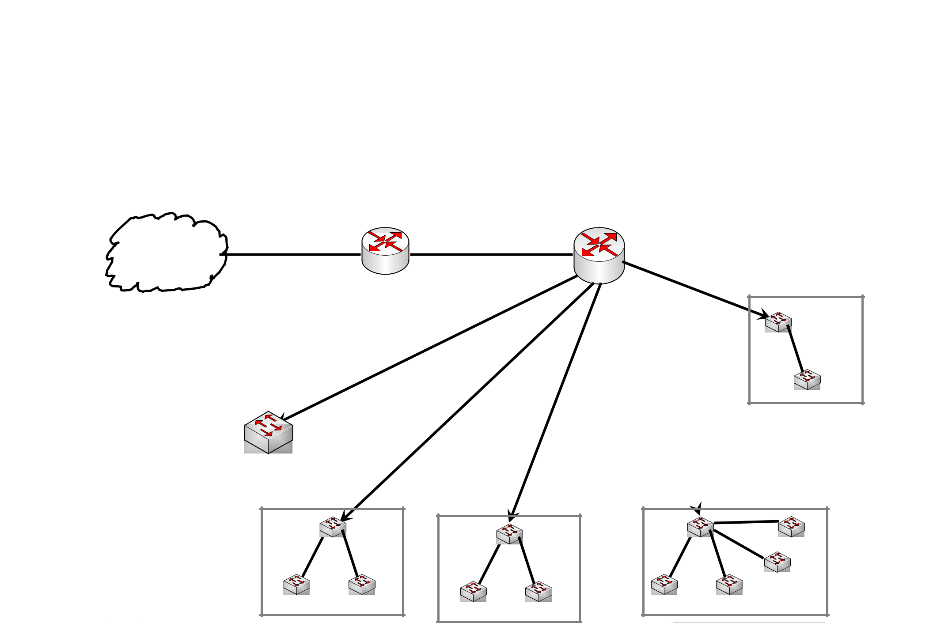
Sample Layer 2/3 Diagram

Cisco 2901 Cisco 3750-12D

Border Router (no NAT) Core Router

62.63.64.32/29 128.223.2.64/29
ISP

128.223.10.0/24

128.223.20.0/24

Server Network

128.223.12.0/23

128.223.14.0/24

Art Faculty

128.223.16.0/24

General Science Faculty

Admin Building Social Science Faculty

Questions?

