**Network Monitoring: Day 3 - Diagram and Descriptions**

This is our classroom network diagram. The workshop is a mixture of virtual PCs and routers as well as physical equipment.

[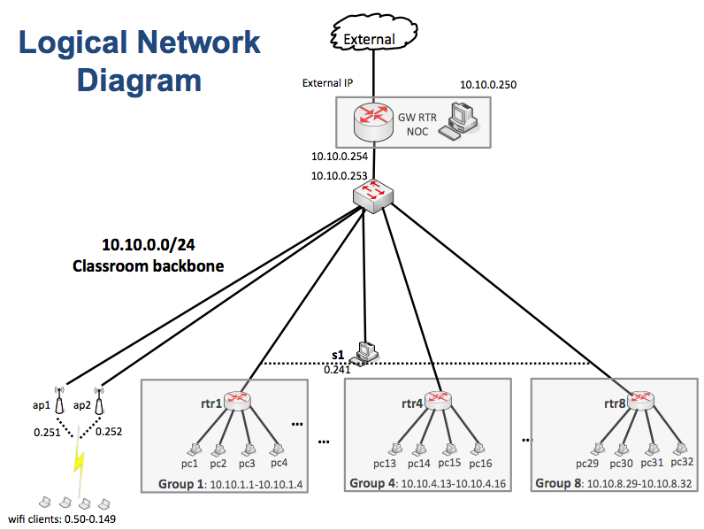](https://nsrc.org/workshops/2012/camren-ait-nsrc/chrome/site/network-diagram-nmm.png)

DOMAIN = ccun.edu.kh

ADDRESSES = 10.10.0.0/24 (backbone)

10.10.1.0/24 (group 1)

10.10.2.0/24 (group 2)

10.10.3.0/24 (group 3)

10.10.4.0/24 (group 4)

10.10.5.0/24 (group 5)

10.10.6.0/24 (group 6)

10.10.7.0/24 (group 7)

10.10.8.0/24 (group 8)

GATEWAYS = 10.10.0.254 (gw.ws.ccun.edu.kh / rtr.ws. ccun.edu.kh)

10.10.1.254 (rtr1, group 1 gateway)

10.10.2.254 (rtr2, group 2 gateway)

10.10.3.254 (rtr3, group 3 gateway)

10.10.4.254 (rtr4, group 4 gateway)

10.10.5.254 (rtr5, group 5 gateway)

10.10.6.254 (rtr6, group 6 gateway)

10.10.7.254 (rtr7, group 7 gateway)

10.10.8.254 (rtr8, group 8 gateway)

Services such as DNS, DHCP, etc. run on NOC = 10.10.0.250

**Nagios Parent Relationships**

**NOC Point-of-View**

Parents are "gw", "sw", "rtr1", "rtr2", "rtr3", "rtr4", "rtr5", "rtr6", "rtr7", "rtr8"

* **gw** ==> sw
* **sw** ==> s1, s2, s3, ap1, ap2, noc, rtr1, rtr2, rtr3, rtr4, rtr5, rtr6, rtr7, rtr8
* **rtr1** ==> pc1, pc2, pc3, pc4
* **rtr2** ==> pc5, pc6, pc7, pc8
* **rtr3** ==> pc9, pc10, pc11, pc12
* **rtr4** ==> pc13, pc14,pc15, pc16
* **rtr5** ==> pc17, pc18, pc19, pc20
* **rtr6** ==> pc21, pc22, pc23, pc24
* **rtr7** ==> pc25, pc26, pc27, pc28
* **rtr8** ==> pc29, pc30, pc31, pc32

**Alternate Logical Network Diagram**

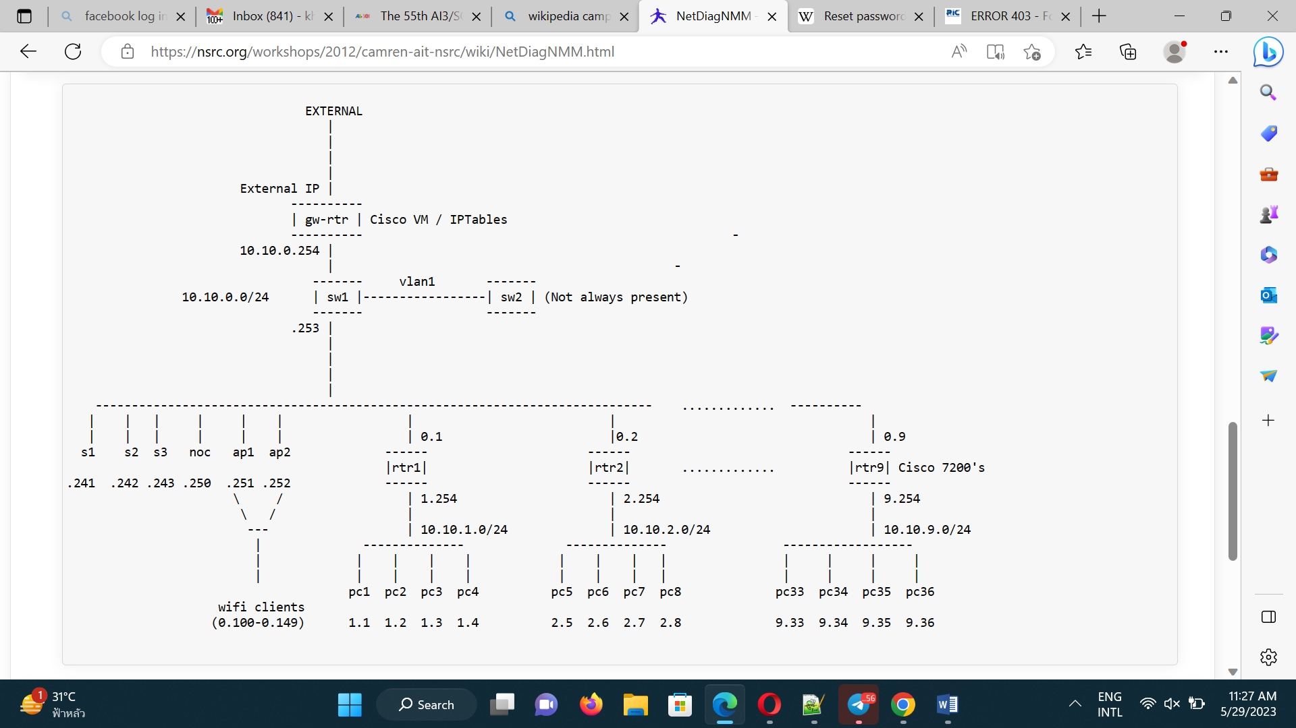

**PCs Address Listing by Group**

|  |  |  |  |  |  |  |
| --- | --- | --- | --- | --- | --- | --- |
|  |  |  |  |  |  |  |
|  | **GROUP 1** |  | **GROUP 4** |  | **GROUP 7** |  |
|  |  |  |  |  |  |  |
|  | **rtr1** ==> 10.10.1.254 |  | **rtr4** ==> 10.10.4.254 |  | **rtr7** ==> 10.10.7.254 |  |
|  | **pc1** ==> 10.10.1.1 |  | **pc13** ==> 10.10.4.13 |  | **pc25** ==> 10.10.7.25 |  |
|  | **pc2** ==> 10.10.1.2 |  | **pc14** ==> 10.10.4.14 |  | **pc26** ==> 10.10.7.26 |  |
|  | **pc3** ==> 10.10.1.3 |  | **pc15** ==> 10.10.4.15 |  | **pc27** ==> 10.10.7.27 |  |
|  | **pc4** ==> 10.10.1.4 |  | **pc16** ==> 10.10.4.16 |  | **pc28** ==> 10.10.7.28 |  |
|  |  |  |  |  |  |  |
|  | **GROUP 2** |  | **GROUP 5** |  | **GROUP 8** |  |
|  |  |  |  |  |  |  |
|  | **rtr2** ==> 10.10.2.254 |  | **rtr5** ==> 10.10.5.254 |  | **rtr8** ==> 10.10.8.254 |  |
|  | **pc5** ==> 10.10.2.5 |  | **pc17** ==> 10.10.5.17 |  | **pc29** ==> 10.10.8.29 |  |
|  | **pc6** ==> 10.10.2.6 |  | **pc18** ==> 10.10.5.18 |  | **pc30** ==> 10.10.8.30 |  |
|  | **pc7** ==> 10.10.2.7 |  | **pc19** ==> 10.10.5.19 |  | **pc31** ==> 10.10.8.31 |  |
|  | **pc8** ==> 10.10.2.8 |  | **pc20** ==> 10.10.5.20 |  | **pc32** ==> 10.10.8.32 |  |
|  |  |  |  |  |  |  |
|  | **GROUP 3** |  | **GROUP 6** |  | **GROUP 9** |  |
|  |  |  |  |  |  |  |
|  | **rtr3** ==> 10.10.3.254 |  | **rtr6** ==> 10.10.6.254 |  | **rtr9** ==> 10.10.9.254 |  |
|  | **pc9** ==> 10.10.3.9 |  | **pc21** ==> 10.10.6.21 |  | **pc33** ==> 10.10.9.33 |  |
|  | **pc10** ==> 10.10.3.10 |  | **pc22** ==> 10.10.6.22 |  | **pc34** ==> 10.10.9.34 |  |
|  | **pc11** ==> 10.10.3.11 |  | **pc23** ==> 10.10.6.23 |  | **pc35** ==> 10.10.9.35 |  |
|  | **pc12** ==> 10.10.3.12 |  | **pc24** ==> 10.10.6.24 |  | **pc36** ==> 10.10.9.36 |  |
|  |  |  |  |  |  |  |